Project Design Phase-II
Technology Stack (Architecture & Stack)

Date | 27 August 2026
Project Name | Employee Raise Issue
Maximum Marks | 4 Marks

Technical Architecture:
The Deliverable shall include the architectural diagram as below and the information as per the table1 & table2.
Example:
Employee Issue Management System
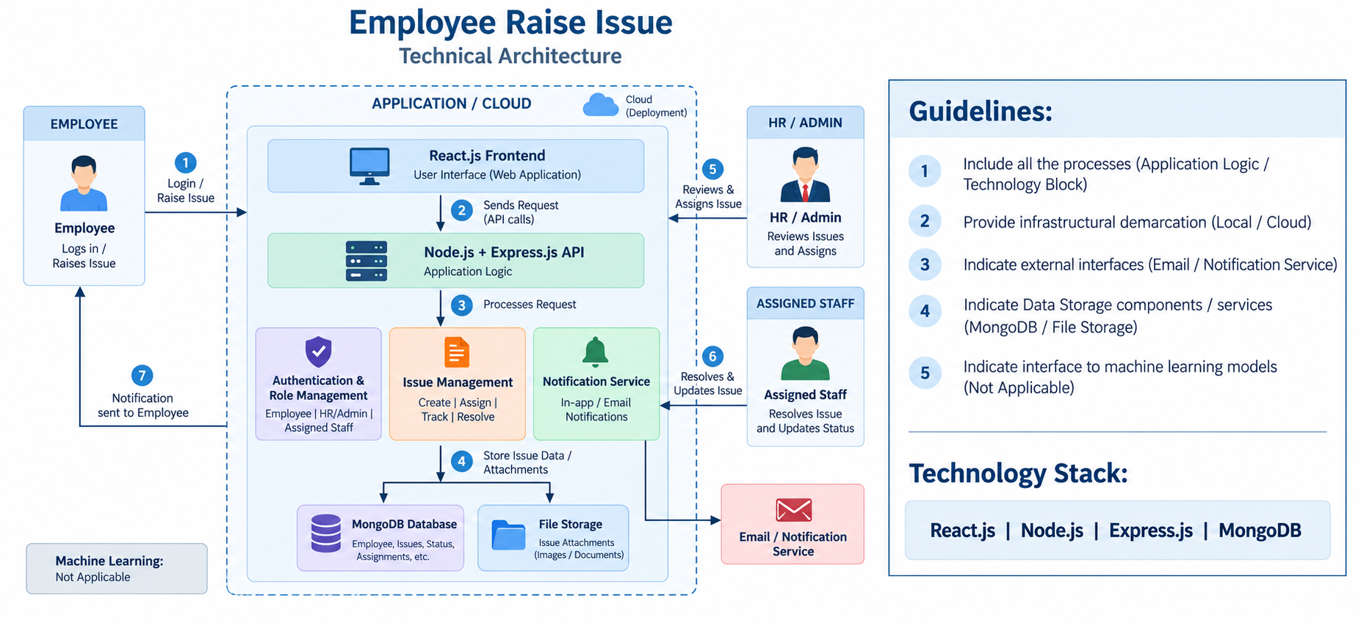

Table-1 : Components & Technologies
S.No | Component | Description | Technology
1 | User Interface | Interface through which employees, HR/Admin, and staff interact with the application. | React.js, HTML, CSS, JavaScript
2 | Application Logic-1 | Handles employee registration, login, and authentication. | Node.js, Express.js, JWT
3 | Application Logic-2 | Handles issue creation, assignment, status tracking, and resolution. | Node.js, Express.js
4 | Application Logic-3 | Handles notifications and communication regarding issue updates. | Node.js, Express.js, Email Service
5 | Database | Stores employee details, issue details, status, assignments, comments, and resolution information. | MongoDB
6 | Cloud Database | Cloud-based database service, if deployed on cloud. | MongoDB Atlas
7 | File Storage | Stores supporting documents and images attached to issues. | Local File Storage / Cloud Storage
8 | External API-1 | Used for sending email notifications to employees. | Email API / SMTP
9 | External API-2 | Used for additional notification services, if required. | Notification API
10 | Machine Learning Model | Machine learning is not required in the current version of the application. | Not Applicable
11 | Infrastructure (Server / Cloud) | Hosts and runs the frontend, backend, database, and storage components. | Local Server / Cloud Deployment

Table-2: Application Characteristics
S.No | Characteristics | Description | Technology
1 | Open-Source Frameworks | Open-source frameworks used to develop the web application. | React.js, Node.js, Express.js
2 | Security Implementations | Secure login, role-based access, password protection, and authentication are implemented. | JWT, Password Hashing, Role-Based Access Control
3 | Scalable Architecture | The application uses a three-tier architecture that can support increasing employees, issues, and departments. | React.js, Node.js, Express.js, MongoDB
4 | Availability | The application can be deployed on a local server or cloud environment and accessed through a web browser. | Node.js Server, MongoDB / MongoDB Atlas
5 | Performance | Optimized database queries and API responses provide quick issue submission, tracking, and status updates. | Express.js, MongoDB Indexing, API Optimization

References:
https://react.dev/?utm_source=chatgpt.com
https://expressjs.com/?utm_source=chatgpt.com
https://expressjs.com/?utm_source=chatgpt.com
https://www.mongodb.com/docs/atlas/?utm_source=chatgpt.com

